豊橋市立 中学校

Toyohashi Municipal Junior High School

入学の手引き
Guide for Entering School

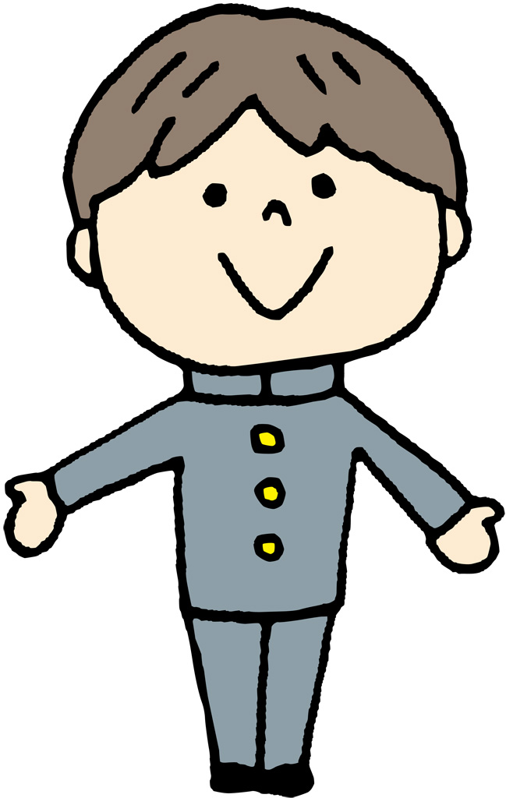
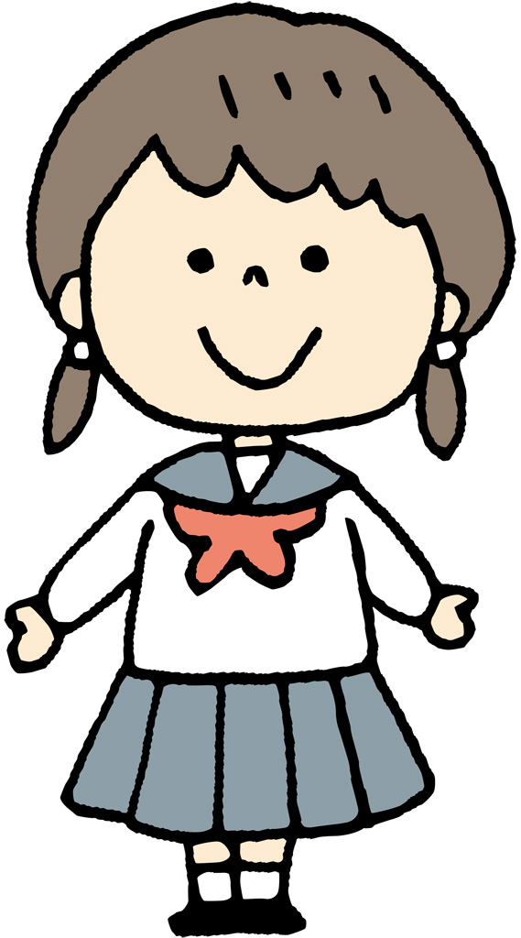

：Address

：Telephone
FAX：FAX

CONTENTS

1. Life in Junior High School 1

2. Curriculum 2

3. School Events 3

4. Course after Graduating 4

5. Money Collection for School Fees 5

6．Entrance Ceremony 5

7. Message from the Nurse's Office 6

8. Homework in Junior High School 7
１ | Life in Junior High School

- Schedule
・ Preliminary bell: :
・ Starting time: : (morning activity)
・ The time that students leave school is based on sunset and varies by season.

- Way to go to school
Walk to school on the designated route to and from school. Some area residents are allow using a bike.

- In case of absence or being late for school
You must call school before the starting time (by 8:15).

- Uniform
① Boys : Winter : Standard school uniform (cap not needed)
Summer: White shirt designated by this school
② Girls : Winter :Uniform designated by this school
Summer: Uniform designated by this school
③ Emblem/Name Badge :
Attach to left breast pocket. *Name badges are ordered at the school.
④ Socks : White socks

5. Uniform for Physical Education (school designation)
① Gym shirt, short sleeves and long sleeves
② Sweatshirt and sweatpants / gym suit (jersey)
③ Gym shorts (girls and boys)

6. Shoes
Schools for going to and from school (sneakers)
Shoes for class
Shoes for physical education

7. Bag for going to and from school

Shops which sells uniforms are listed below:

２ | Curriculum
 | 1st Year | 2nd Year | 3rd Year
Japanese | 4 | 4 | 3
Social Studies | 3 | 3 | 4
Mathematics | 4 | 3 | 4
Science | 3 | 4 | 4
Music | 1.3 | 1 | 1
Arts | 1.3 | 1 | 1
Physical Education | 3 | 3 | 3
Technology & Home Economics | 2 | 2 | 1
English | 4 | 4 | 4

 | 1st Year | 2nd Year | 3rd Year
Combined subject | 1.4 | 2 | 2
Morals | 1 | 1 | 1
Class Activities | 1 | 1 | 1
Discretionary | 1 | 1 | 1
Total | 30 | 30 | 30
(a unit per week)

Junior High School Classes

◎Different subjects taught by different teachers:
The teacher teaching the class changes for each subject. The pace of the class and homework are different for each subject.

◎Class hours:
In some schools, school starting time and class hours will change between summer and winter.
Summer: 50 minute classes / Winter: 45 minute classes

◎Evaluation:
There are several regularly scheduled tests throughout the year. Evaluations will be made by adding together test scores, skill test scores, the student’s attitude in class, and work submitted.

Measures against Truancy / Skipping School / Bullying

As measures against truancy and bullying, the school identifies the rate of absenteeism and offers classes to adapt to school and educational counseling with counselors and lifestyle support instructors. We also offer students multifaceted support through cooperation with the City of Toyohashi’s psychological counselor and “TOYOHASHI HOTTO PLAZA”, a separate facility.

３ | School Events

Regularly scheduled tests |  | Month:
Entrance Ceremony |  | Month: | In-school Competition |  | Month:
Outdoor Activity |  | Month: | Culture Festival |  | Month:
Sports/Field Day |  | Month: | Farewell Party for 3rd Year Class |  | Month:
Chorus Contest |  | Month: | Graduation Ceremony |  | Month:
1st Year | Nature Event (camping) |  |  | Month:
2nd Year | Vocational Education (job shadowing) |  |  | Month:
3rd Year | School Trip |  |  | Month:

Club Activities

◎Preference-based system:
You chose which club you want to join. Costs vary for each club. You have to pay the costs for club activities.
◎Days of activities:
Monday to Friday, after school. Some clubs have activities on weekends and holidays and during long vacations. The days of activities varies for each club.
◎Competitions:
General Sports Meet in summer, First Year Sports Meet in autumn, and other competitions officially recognized by the Toyohashi Municipal Board of Education

The clubs you can chose is depend on schools
Sports Clubs |  | Culture Clubs
Baseball | Soft Tennis | School Band
Track and Field | Table Tennis | Choir
Soccer | Swimming | Art
Basketball | Kendo (Japanese fencing) | Computer
Volleyball | Judo | Home Economics
Handball | Kyudo (Japanese archery) | Taiko (Japanese drums)
４ | Course after Graduating

The following shows the status of foreign students who graduated in the 2024 (Reiwa 6) school year (graduated March 2025).
143 out of 130 foreign students entered high schools and vocational schools.

Prefectual High Schools | number | Private Schools | number
Mitoaoba | 37 | Sakuragaoka | 5
Toyohashi Kōka | 11 | Fujinohana | 6
Toyohashi Nishi | 5 | Toyohashi Chūō | 6
Toyokawa Kōka | 4 | Seika Gakuen | 1
Jisyūkan | 1 | Toyokawa | 1
Toyohashi Higashi | 1 | Hikarigaoka | 1
Toyooka | 1 | Mikawa | １
Toyohashi Syōgyō | 1 | Private Schools outside of Aichi | １
Kofu | 1 | Vocational Schools/Specialized Training School | 4
Miyasuisan | 1 | Brazilian school, Other | ２
Municipal High School | number | Job, Other | １３
Toyohashi | 27

Options for Foreign Students

・Over the past several years, the number of foreign students continuing to high school has been increasing. Graduating from high school will be very useful when seeking a job.
・It is too late to start thinking about what to do after graduating from junior high school once you have reached the 3rd year. Starting thinking about it from the moment you start junior high school.
・Your attendance, your attitude in class and toward school, and your attitude toward life will influence your entrance examination for high school. Try to avoid absences as much as possible.

From a non-Japanese student who graduated from a Japanese school

“When I started the first year of the junior high school, I was very nervous because I did not speak Japanese and I knew nothing at all about Japanese culture. However, as I learned Japanese little by little, school became more and more fun. After graduating, I entered a night school and studied while working. Sometimes I was reluctant to go to school because I felt tired after work, but I did my best and graduated from high school. Now I am working as an interpreter. On holidays I go out with my friends from school, and I am enjoying my life. Please study hard and graduate from school, not for someone else, not for your parents, but for yourself. Hold onto your dream and work hard to make it come true.”

５ | Money Collection for School Fees
1. Automatic bank transfer on of every month.
The amount collected each month is around 8,000 – 9,000 yen.
*The fees at the beginning of the year may be higher than this amount.
This includes school lunch fees, costs of texts used in class, PTA fees, etc.
2. You should use a “regular savings account” (futsū yokin kōza) at one of the
Following banks.
3. Please refer to the sample form when filling in your form.
Banks designated by this school:

６ | Entrance Ceremony

Junior high school Entrance Ceremony

1. Date: _____ /____ /____ _ (year/month/date)
2. Program:
・Announcement of Classes :
・Reception : ― :
・Doors Open :
・Start of Ceremony :

７ | Message from the Nurse’s Office

Now that your children have almost graduated from elementary school, both parents and students may be looking forward to a new school life with stress and anticipation. In order that they will have a pleasant and fruitful time in junior high school, the school nurse officers the following information and advice.
Dokuritsu Gyōsei Hōjin Nihon Sports Shinkō Center (National Agency for the Promotion of Sports and Health)
This school insurance system covers all accidents that occur while under school supervision.
① Annual Premium 460 yen for the school year
② Enrollment/Consent Form Valid for 3 years

All students at all schools (including elementary schools) in Toyohashi enroll in this insurance plan.

Check on your child's health condition before he/she goes to school
Check how your child looks or acts before he or she goes to school. If he/she looks unusual, please talk with him/her, check his/her body temperature, and find out the reason why. Then, decide whether or not your child should go to school.

How school nurses take care of students in the nurse’s office
①In case of injury:
Injuries that can be treated at school will be treated at school. If the school determines that the injury should be treated a hospital/medical institution, then the student will be taken to a nearby medical institution. Before taking the student to a medical institution, the school will try to contact the parents/guardians. If the school is unable to contact a parent/guardian, then the school will contact a parent/guardian after taking the student to receive treatment.
②In case of illness:
If a student has a fever and cannot attend classes, the school will contact the student’s home and send him/her home early.
If a student feels ill and cannot attend classes, he/she will stay under observation in the nurse’s office for approximately one hour. If the student does not recover, he/she will be sent home early.
No medicine will be given to students.
③In the event that a student is sent home early:
In all cases, the school will contact the student’s parents/guardians when sending him/her home early.
④Emergency Contact Information
If a student ever becomes ill or is injured at school, the school will contact the student’s parents/guardians. However, there are some cases where the school is unable to contact the student’s parents/guardians because their telephone number has changed or for some other reason. Therefore, please write a number where you can definitely be reached when filling out the “Home Environment Survey” (Katei Kankyou Chousa-hyou) and “Health Card” (Kenkou Kaado). If there is a change to your contact information, please let your child’s homeroom teacher know as soon as possible.
８ | Homework in Junior High School

A lot of homework will be given out every day in junior high school. Doing homework every day will help build good habits for studying alone. Studying at home is essential for continuing studies into high school.

① All junior high schools will have students use “Seikatsu Nikki,” a notebook where students write down the schedule for each day. Students write the next day’s schedule and assignments in this notebook, and it is important for remembering what to prepare for the next day’s classes. This notebook is also used as a dairy that students write in every day. If you have difficulty writing Japanese, then it may be hard to write every day, but writing daily will improve your ability over time.

② There are assignments given to all students of a given grade each day in junior high school. (Many schools call these assignments “heijitsu kadai” and “kyuujitsu kadai.”) These assignments take about one hour each day.

③ There are assignments for each subject. For example, in English class, the assignment might be to write a notebook page of vocabulary words; in Japanese, the assignment might be to practice writing kanji. Kanji and English vocabulary are difficult to memorize without writing them over and over, so this kind of repetitive practice is very common. There are also assignments called “kyouka work” given out for each subject. “Kyouka work” assignments are more often done at home than during class time.

④ Classes will also have assignments called “Tangen matome print” (Unit Summary Printout). These follow a test format and follow each unit of the textbooks.

In junior high school, the “answers” to all this homework will also be given to the students. If you still have difficulty with Japanese, then is ok to just do as much as you can at your level. For example, when doing math assignments, you could solve the calculation problems by yourself without looking at the answers, and then for word problems, just copy the formulas from the answer sheet and do the calculations yourself. Doing this should help you at the normal speed for your grade. For Japanese and social studies, instead of refusing to do the assignments because you do not understand Japanese, you should at least look at the answer sheet and copy if necessary. Doing this will help you gain good study habits and improve your long-term academic ability. In addition, “Submission” of these assignments is very important for junior high school students. Your grades will not just be based on your test scores, but will also reflect the submissions you have made for assignments. “Kyouka Work” assignments must be turned in before the regularly scheduled tests, so it is important not to forget these.

※Feel Free to Ask Anything About This School

If you have a question or issue, please call:

(1) Toyohashi Shiritsu Chūgakkō ☎ (0532) ―

Person to contact:

(2) School Education Division
(Toyohashi City Hall, East bldg. 11th floor) ☎ (0532)51-2827

(3) Counselor’s bureau for foreign students
(Toyohashi City Hall, East bldg. 11th floor) ☎ (0532)51-2077

■Consultation in Portuguese
Monday | Tuesday | Wednesday | Thursday | Friday
9：00 ~ 16：00

■Consultation in Spanish and Tagalog
Monday | Tuesday | Wednesday | Thursday | Friday
Tagalog  11：00 ~ 15：30 | Spanish  11：00 ~ 15：30 | Tagalog  11：00 ~ 15：30 |  | Tagalog  11：00 ~ 15：30

■Consultation in simple Japanese
Monday | Tuesday | Wednesday | Thursday | Friday
13：00 ~ 17：00

