年 月 日
保護者 様 豊橋市立〇〇〇〇〇学校
Dear Parents/Guardian (Name of school)
校長
(Name of Principal)
Submission of “The school life guidance & management form（For Food allergy & Anaphylaxis） “Gakkou seikatsu kanri shidou hyou”
学校生活管理指導表（食物ｱﾚﾙｷﾞｰ・ｱﾅﾌｨﾗｷｼｰ用）の提出について（依頼）

Greetings! We would like to thank you for submitting the Health Questionnaire form during the Health checkup of your child. This Survey is only for the guardian who answered to the previous Questionnaire that “Their child has a Food allergy and needs special consideration”.
This time, we would like you to submit another form, which is “The school life guidance & management form （For Food allergy & Anaphylaxis）” (Gakkou seikatsu kanri shidou hyou) so that the school will understand the details and be able to correspond correctly. We thank you for your understanding and please submit the “The school life guidance & management form (Kanri shidou hyou)”.
We have enclosed the said form and please submit it on the ___(month) ____(day) during the
School Entrance Ceremony Orientation

１．Form need to submit 提出書類
“The school life guidance & management form” (Kanri shidou hyou) 「管理指導表 For School’s Record学校保管用」
・ Please visit a doctor in order to fill in the form.
- We recommend you consult with a doctor (Allergology)
・ “The school life guidance & management form” (Kanri shidou hyou) is required to be submitted every year to school even there is no changes in symptoms as long as your child needs special countermeasure. (You are required to submit it every time there is a big change in symptoms)
- Please keep the House’s Record家庭保管用 and refer to it for the proper countermeasure. Also, bring it to the Medical Institution when you undergo an examination.

２．Interview after submitting “The school life guidance & management form” (Kanri shidou hyou)
提出後の面談について
After the submission of “The school life guidance & management form” (Kanri shidou hyou), the school and guardian will discuss (meeting or telephone) about the countermeasure for the safety of child.

３．Usage of “The school life guidance & management form” (Kanri shidou hyou) 活用について
The school will discuss on how your child can spend time at school safely by referring to the “The school life guidance & management form” (Kanri shidou hyou) and by conducting meeting (Phone call) with guardians. The school will show this form to the Fire services body(For ambulance) and Medical services body during the emergency condition.

４．The others その他
・ It may take a few days for the release of “The school life guidance & management form” (Kanri shidou hyou),
please visit the doctor as early as possible.
・ Please avoid the influenza season for the examination.
４ その他
・「管理指導表」の記載には、日数を要する場合がありますので、余裕をもって受診するようお願いします。
・受診にあたっては、なるべくインフルエンザの流行期を避けるようお願いします。

◆Please call the school for any questions（○○○学校School 電話TEL 0532－ － ）
不明な点がありましたら、学校までご連絡ください。（○○○学校 電話 0532－ －‥‥‥）
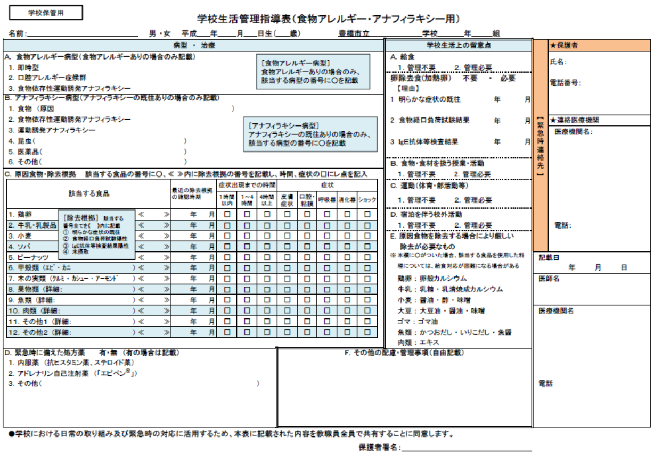
I agree that the information on this form may be shared with school staff from another school for daily activity use
and emergency purposes.

Signature

保護者が下記①・②の欄を記載し、学級担任まで提出してください。
Parents and guardians, please fill in areas ① and ② below, and return to your child’s homeroom teacher.

➀
➁
医師から、「学校での配慮や管理は不要」と口頭で指示があった場合は、保護者で下記①・②・③の欄を記載し、学級担任まで提出してください。
If the Doctor diagnosed that your child doesn’t need special consideration/management, Pls. fill up 3 items①②③ and submit the form to school.

名前： （男・女）平成 年 月 日生（歳） 豊橋市立 学校 年 組 提出日 平成 年 月 日
ＮＡＭＥ： (Male・Female) B-day: Heisei Y.r Month Day (Age) Toyohashi Municipal ___________School Grade ____ Section ___ No.__ Submitted on Heisei Yr. Month Day

