平成 ○年 ○月 ○日
HEISEI(Year) (Month) (Day)
To Parents/Guardians of
○年○ 組○ 番 さん 保護者様
(Year) (Sec) (No)
Toyohashi Municipal School
豊橋市立 学校
校 長 ○○ ○○
(Name of Principal)
成長曲線の結果のお知らせ
Growth curve Analysis result
Below is the findings based on the result of your child’s growth analysis (The one with circle).
Please consult your Doctor if you have any concerns. When you consulted a Doctor, kindly fill up the Form below and submit it to school afterwards for the school’s future reference.
お子様の成長曲線について、下記のような特徴がみられましたのでお知らせします(○印)。気になる方は、かかりつけ医にご相談ください。
なお、受診された場合は、今後の保健指導の参考にもしたいと思いますので、受診の結果について保護者で記入し、ご報告ください。

Height growth rate is higher than Average
成長曲線の標準と比べて身長の伸びが大きいです
Height growth rate is lower than Average
成長曲線の標準と比べて身長の伸びが小さいです
Suspisous of Short stature
低身長の疑いがあります
Tend to become obese (Progressive)
肥満傾向です（進行性）
Tend to become skinny (Progressive.)
やせ傾向です（進行性）

参考 成長曲線（身長曲線・体重曲線）とは
◆Reference: What is Growth Curve(Height curve ・Weight curve)
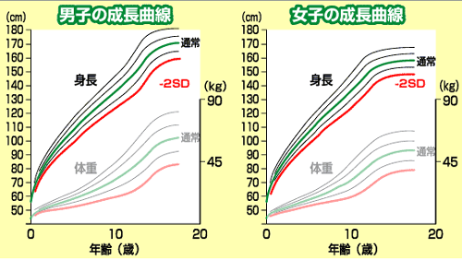
“Growth Curve” is a set of data that measures the rate of growth in height and body weight from child’s birth to Adulthood. Maternal and Child Health Law requires that it should to be posted on the Mother & Child Health Book and therefore maybe you are familiar with this graph. Differences in growth are natural among individuals, and the Growth curve acts as a baseline for comparison.
Many growth abnormalities are caused by Growth hormone/
Thyroid hormone and brain tumors, which can be treated if
discovered early.
It is difficult to find abnormalities in a one-time measure. We recommend you to draw a Growth curve because ①it will help you to discover abnormalities in early stage ②it will assure you that your child is developing in a standard manner.

受診報告書
Consultation Report

1. Instruction given by the Medical specialist 専門医から受けた指示
□ 治療・経過観察の必要なしNo need for further treatment nor observation
□ 経過観察 Observation needed
□ 治療の必要あり Medical treatment is needed
□ 治療中 Under treatment
□ 生活上での注意事項 Things need to take into consideration in daily life

2. Name of the Clinic/Hospital 医療機関名

平成 年 月 日 保護者名
HEISEI (year) (month) (day) (Name of Guardian)
ew19naika04(2017)

